

ASIA PACIFIC COLLEGE

ONLINE PRE-REGISTRATION

SYSTEM

RUIZ, Angelica Laurene S.

Project Manager

ROGUEL, Jairus Adrian G.

System Developer

GLORIA, Romulus Diego P.

System Analyst

Submitted on:

August 23, 2016

Submitted to:

Mr. Manuel Sebastian Sanchez

* 1. INTRODUCTION
  2. PROJECT CONTEXT

The online pre-registration system project will be integrated with the FLAVIO system of Asia Pacific College (APC) and will be solely used by the APC community. With the use of the system, adding of subjects is taken into the next level. It eliminates the inconvenience of going to different places inside the school to successfully pre-register. It is just one click away from gadgets.

The system first requires authentication (username-password) to access FLAVIO and when students are logged in, they can access the pre-registration system along with the other systems such as Grades Viewer, Flowchart, Assessment Form and Masters List. When they open the pre-registration, they can input subjects they would like to add in their flowchart and that would be sent to the system as a request. The system sends it to the adviser, then approves or disapproves the request. After approving, the registrar updates the masters list and students’ flowchart.

1.2 PURPOSE AND DESCRIPTION

All schools have systems created for students like Enrollment, Pre-registration, Grades Checker, Flowcharts, and Teachers Evaluation. With the use of technology, those features are being used online for easier access and convenience. But, not all schools have all features online.

In Asia Pacific College (APC), the pre-registration system is currently manual wherein students can add subjects in their load in the given period for pre-registering. But before that, program directors of different courses create subjects then passes it to the registrar for verifications like conflicting schedules and correct number of units. Then, the registrar updates the Masters List, where all subjects of all courses and its room, schedule and time is posted. Students are assigned in block sections that follows the same track of subjects and can view it at the Online Student’s Flowchart. The pre-registering starts when a student wants to add subjects due to failure in grades or to be ahead in the track of subjects. Certain steps are needed to be followed by students to successfully add a subject in their load. Problems arise in some of the steps resulting to inconvenience like conflicts of the schedule of the adviser and student and wrong input of subjects in students’ flowchart.

Thus, the researchers proposed an online pre-registering system project to satisfy the students, eliminate such problems (ex. conflicts in schedules, crowded offices) and maximize resources. The focus of this project is the students and their satisfaction because they greatly affect all aspects of the school. For example, if a room is too hot, students would not be able to focus properly and will be uninterested in listening to professors because they need a proper temperature in their classroom, thus, the school provides air conditioners. It is the same with the purpose of this project, which is to provide students what they need to satisfy them and to diminish inconvenience in manual pre-registration.

The project would be a new feature in APC’s FLAVIO System which students can access through Internet in <https://www.apc.edu.ph/flavio/inquiry/Login.php>. Its existing features include Online Grades Viewer, Student Flowcharts, Masters List and Registration Form. An online pre-registration feature can provide easier accessibility for students and convenience. It eliminates issues in manual pre-registering like conflicts in special cases, waiting time for the adviser in their office and the inconvenience of walking up and down the stairs.

* 1. OBJECTIVES

The objectives of the project are:

* To understand the flow of the current pre-registration process
* To build a prototype of the online pre-registration system
* To collect data from students about their feedback on the pre-registration system
* To look for sample algorithms that may serve as a basis for working on the project
* To provide convenience and satisfy the students, advisers and APC Community
  1. SCOPE AND LIMITATIONS

The online pre-registration project will be solely used by the APC Community. It will be integrated with the FLAVIO System for easy access and will require authentication for security purposes. Adding of subjects will be the project’s main feature. Once a student fills up the required fields for adding a subject, the request will be send to the system where it sends the request to an adviser. Crashing of the pre-registration feature due to error in the code will be examined by the group members about such problems like overloading of database will be examined by the ITRO staff. Also, special cases (ex.: accreditation of subjects, advance taking of subjects, adding a subject even if maximum units are already met, etc.) would be settled manually for it requires human interaction in order to analyze more whether it is allowable.

* 1. RELATED LITERATURE

ATENEO INTEGRATED STUDENT INFORMATION SYSTEM (AISIS)

The Ateneo Integrated Student Information System (AISIS Online) is the portal for Ateneo students, faculty and staff. Through the AISIS Online, officially enrolled Ateneo students may view pertinent school information including their IPS, grades, class schedules and the like. Students may also eventually enlist using AISIS Online. Ateneo faculty and staff with access to AISIS, on the other hand, may submit grades and access their class schedules from outside the campus.

Our project is similar in a sense that our system would like to use the web to provide the user information concerning his/her subjects that would like to be modified. AISIS Online provides an Online Enlistment service that would give the students the convenience of modifying their subjects online. One of our project’s objectives is to provide convenience and satisfy the students, advisers and APC Community. With this related literature, we can adopt or implement ideas that we have reviewed in the system and implement it to our proposed system. (Retrieved on August 19, 2016 from <http://aisisonline.ateneo.edu/index.php>)

DE LA SALLE UNIVERSITY ANIMO.SYS PORTAL

De La Salle University has an online enrollment system which is Animo.sys portal that students can access for encoding the courses they want to take for the next term. Enrollment schedules are posted for students to know when to enroll. All students must have an activated My.LaSalle account to access the enrollment system open from 8 am until 8 pm during Mondays to Fridays in <http://my.dlsu.edu.ph>/. They must arrange all clearances first before or during the enrollment schedule. Students may have academic advising from the Graduate Program Coordinator of your course which is discussing about the subjects that students want to add. Then, students can check the course codes of the subjects they want to take. Schedules are given for students on when to enroll online. After enrolling, they may claim the Enrollment Assessment Form (EAF) which contains all the subjects they have encoded.

The features that Animo.sys Portal has some features similar to the manual pre-registration system of Asia Pacific College. For example, both systems provide course codes for students to know what subjects they want to add. Another is that both have academic advising for students to be notified whether they can take the subject or not due to different cases like failed pre-requisites, unfinished clearances and unpaid tuition fees. By having a background of how Animo.sys Portal works, it will be a great basis for creating our proposed project which is Asia Pacific College Online Pre-Registration System. (Retrieved on August 19, 2016 from https://my.dlsu.edu.ph/faq/, http://www.dlsu.edu.ph/offices/registrar/enrollment.asp)

UNIVERSITY OF THE PHILIPPINES COMPUTERIZED REGISTRATION SYSTEM (UP CRS)

The Electrical and Electronics Engineering Institute in the University of the Philippines made an explanation about how the University of the Philippines’ Computerized Registration System (UP CRS) works. Students usually go through advanced enlistment and enlistment during general registration. They also have advanced enlistment in the middle of the period. During advanced enlistment students would submit a list of their desired subjects to their respective colleges. These lists are submitted online through the UP CRS. The UP CRS then processes these list according to the student’s enrollment status. The results are to be printed as the UP Form 5-A. During the registration period, the subjects can be added or dropped from the Form 5-A due to different reasons. Then the different colleges would allocate new slots to those subjects that have been dropped by the students. These slots can be viewed in the UP CRS.

The UP CRS has the flexibility we would like our Pre-registration to have. The UP CRS has an option to add, drop and petition subjects online. The UP CRS can also show available slots to all subjects offered just like what APC has which is the Masters List. The UP CRS would be a great basis on what functionalities our Pre-registration system would have. (Retrieved on August 19, 2016 from <http://www.eee.upd.edu.ph/academic-programs/enlistment/computerized-registration-system>)

* 1. TECHNICAL BACKGROUND

The framework used for creating the project is latest version of Cobalt which is mark IV - build 20160307. In order to access Cobalt, XAMPP must be downloaded in order to use Apache and MySQL modules in the XAMPP Control Panel and access the localhost. The FLAVIO System of APC uses Cobalt as its framework, thus the project is obliged to use the framework also because the Online Pre-Registration System is to be integrated with FLAVIO.

When implemented, APC students can access <https://www.apc.edu.ph/flavio/inquiry/Login.php> using their existing accounts then view the “Pre-Registration” which is a new system added in FLAVIO.

* 1. DESIGN AND METHODOLOGY

To create the design of the prototype, Cobalt framework and XAMPP is used. In XAMPP Control Panel, Apache and MySQL module is started then access the localhost at preferred browser, for the project, Google Chrome is used. In localhost/phpmyadmin, an SQL File named cobalt is imported in order to access localhost/cobalt and the database for pre-registration is created. In localhost/cobalt, the project prototype can be created and the database created in phpmyadmin is used for the prototype. The tables from the database of the pre-registration is also used for the prototype. After generating the project created in localhost/cobalt, a new folder with new files of the prototype is created inside \xampp\htdocs\cobalt\Generator\Projects. The folder is cut and pasted in the webroot (\xampp\htdocs). After that, the project can already be accessed on the web browser in localhost/nameofproject.

For the project, there are two main users which are the root and the student (user). The student can add subjects for the following term. The root can edit other tables like the subjects offered and schedules.

Current Prototype

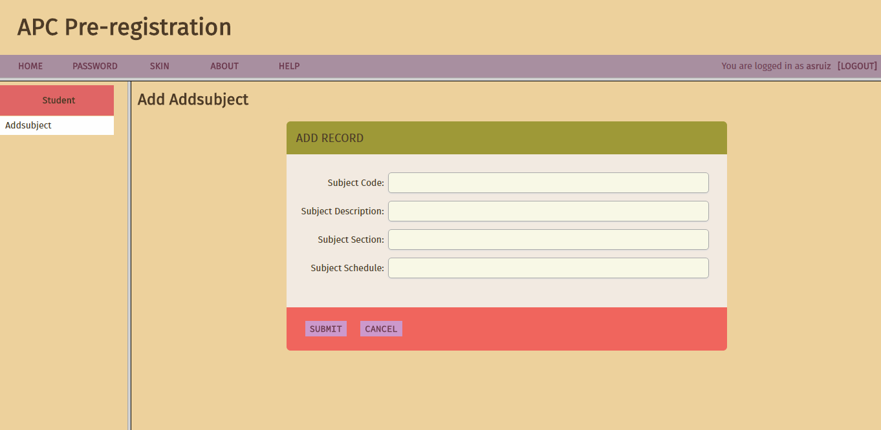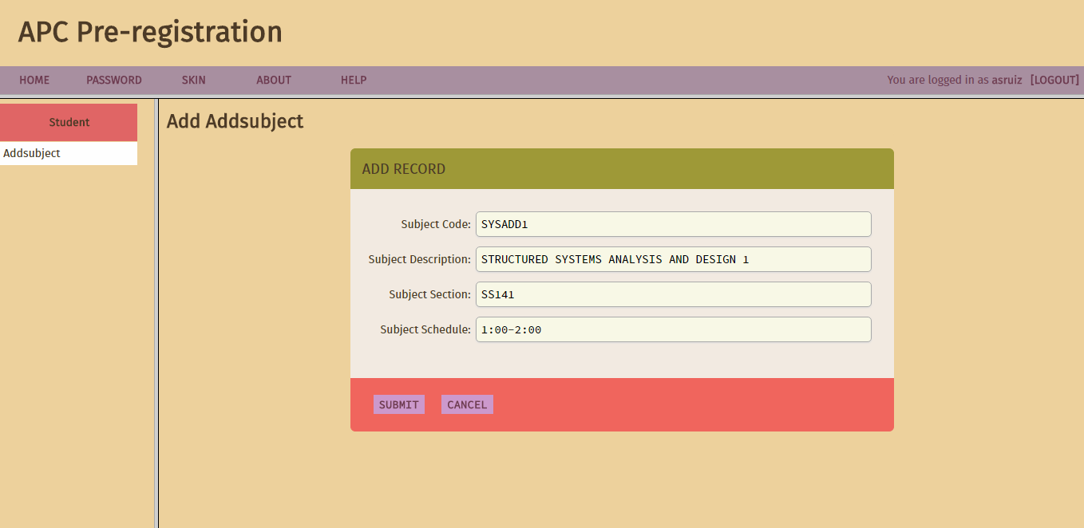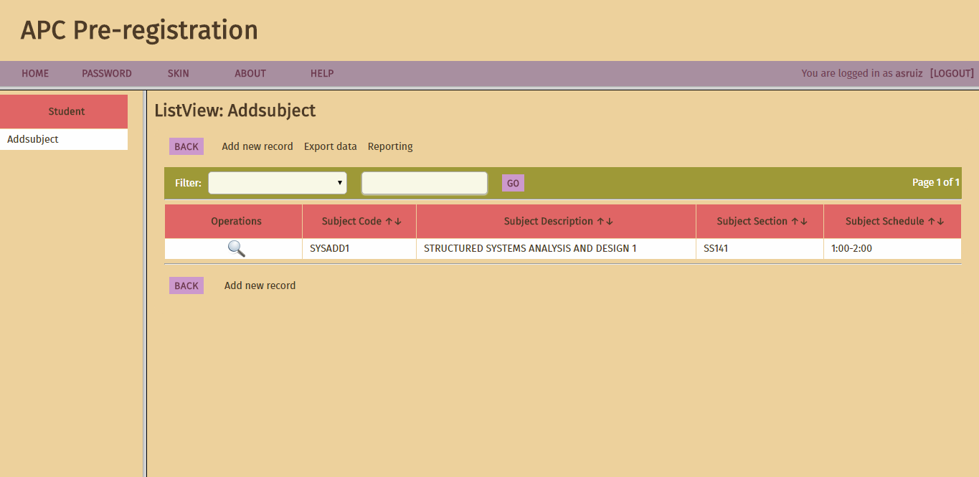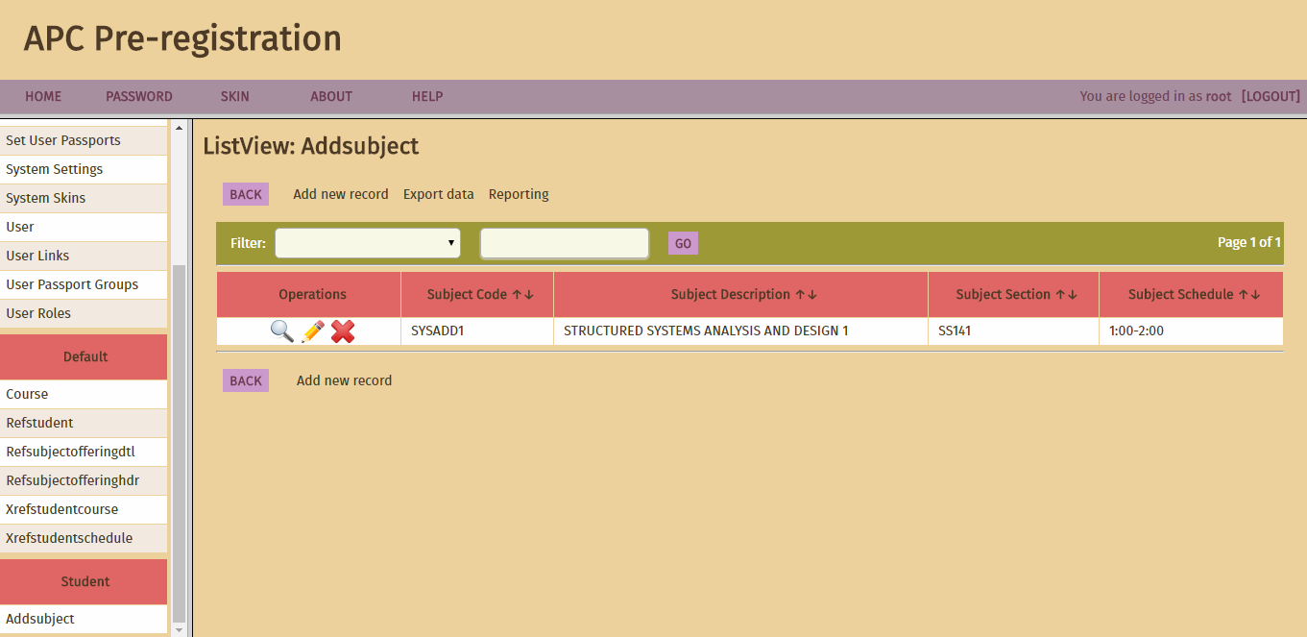

DATA COLLECTED

We conducted a quick interview with students of Asia Pacific College. The sample size is currently 10 because we have interviewed 10 students from APC. More students will be interviewed.

The questions asked are:

|  |  |  |  |  |  |  |  |
| --- | --- | --- | --- | --- | --- | --- | --- |
| Name | School | Course | Year Level | Have you experienced pre-registering? | Are you satisfied? | Comments/  Recommendations/  Suggestions | Rate your satisfaction (1-5)  1 – lowest  5 – highest |

Summarized Data:

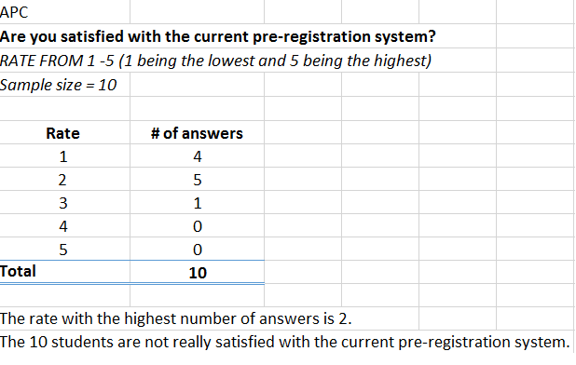

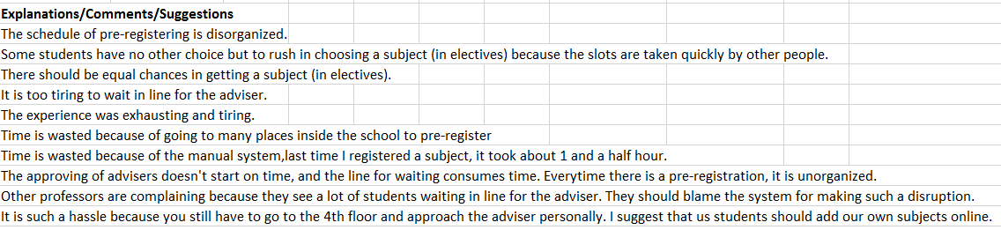

APPENDICES

Communication Diagram

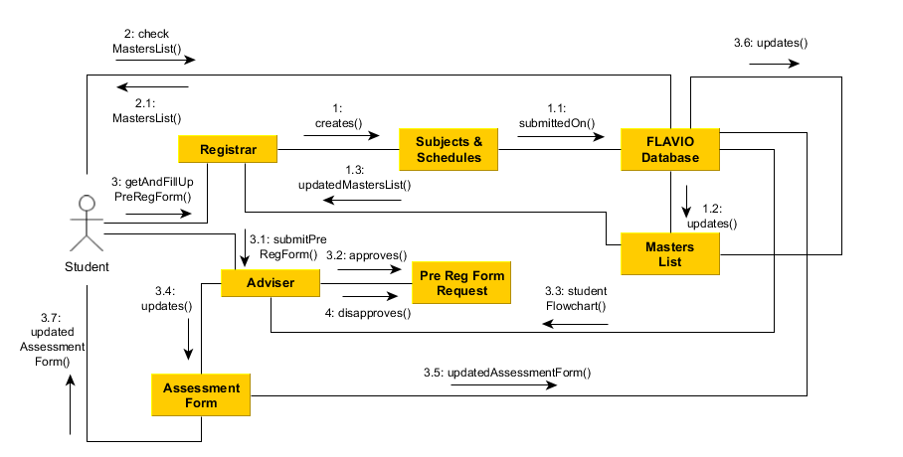

Activity Diagram

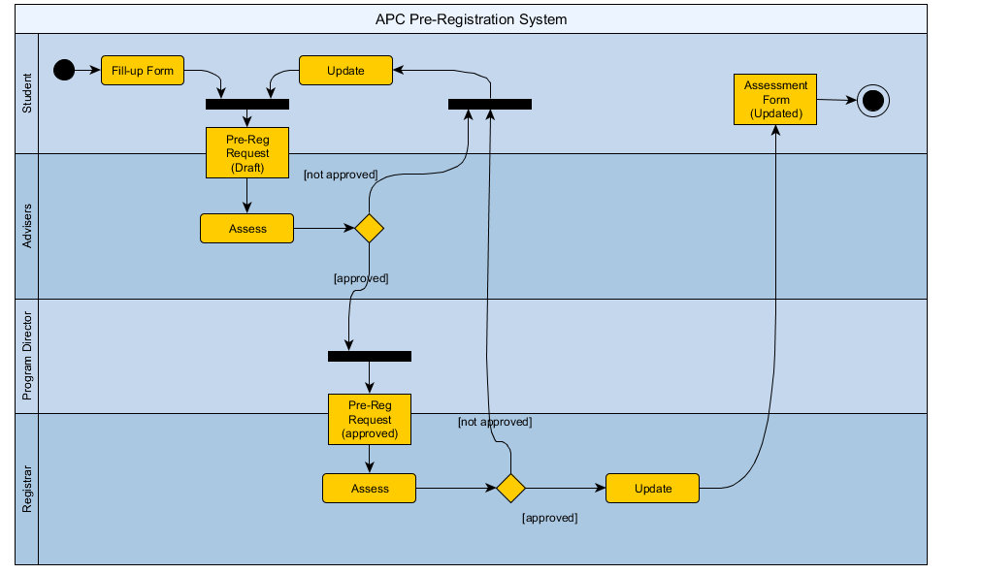

Class Diagram

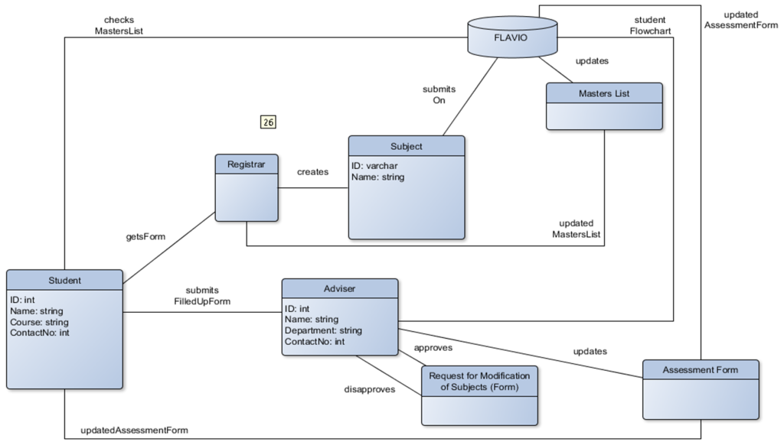

Object Diagram

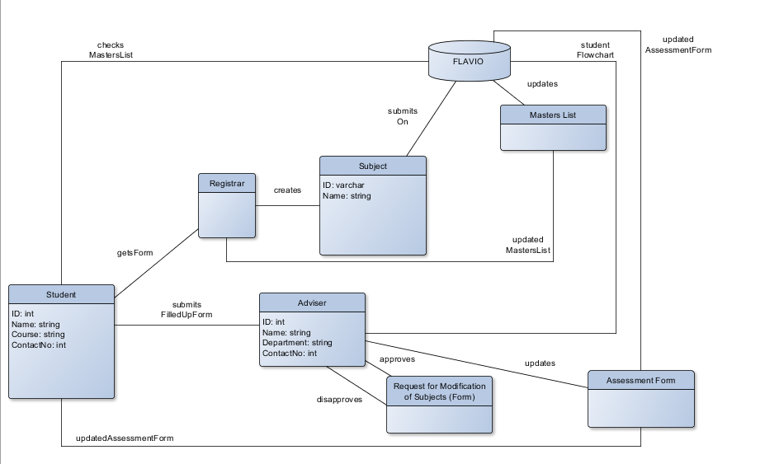

Composite Diagram

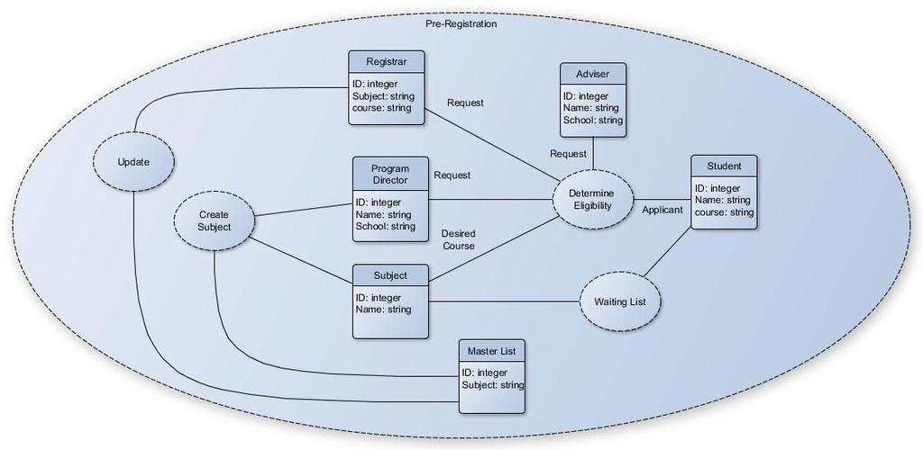

Deployment Diagram

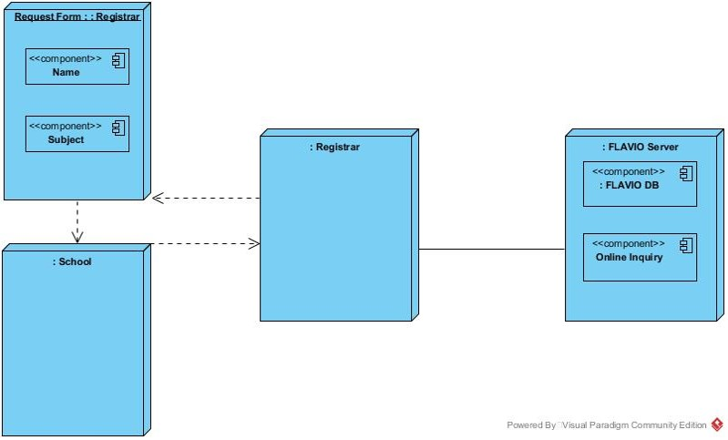

Component Diagram

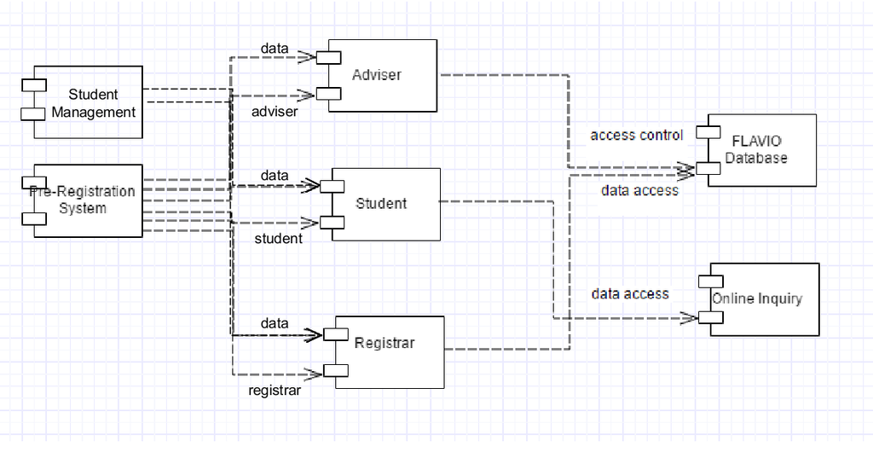

Timing Diagram

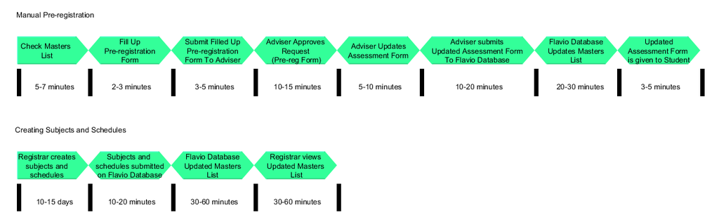

State Machine Diagram

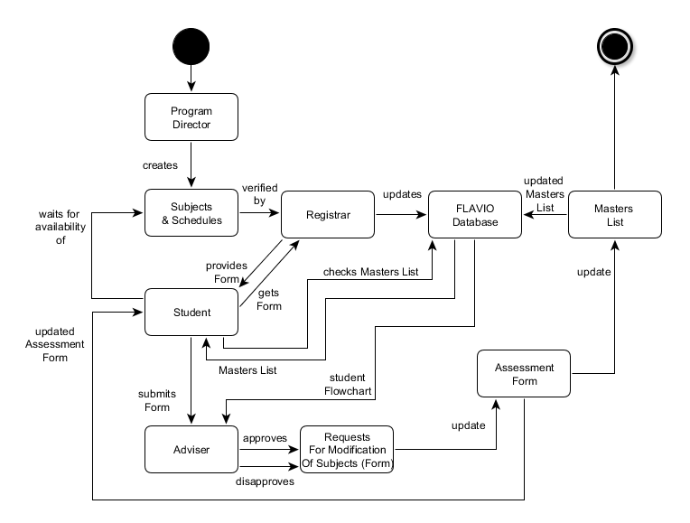

Use Case Diagram

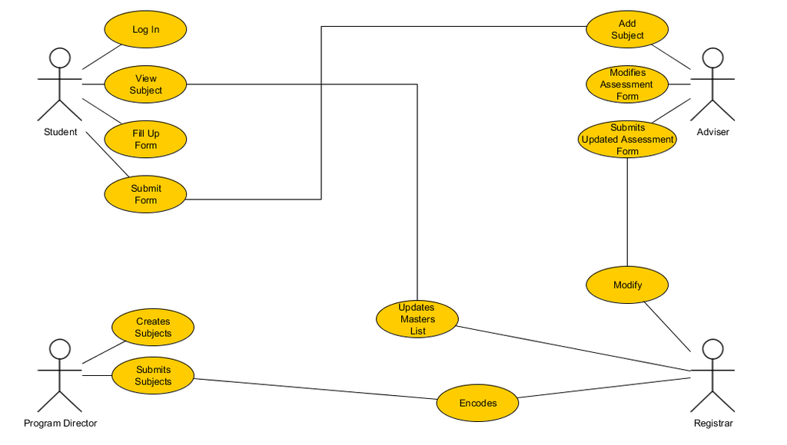

Package Diagram

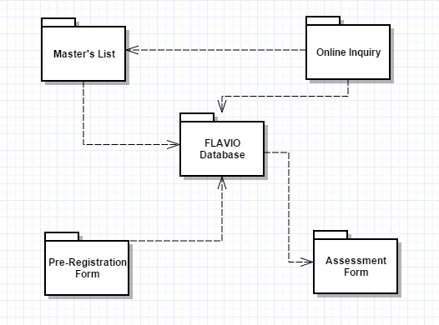

Sequence Diagram

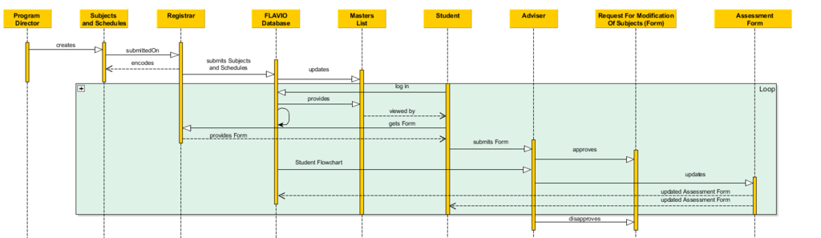

Interaction Overview Diagram

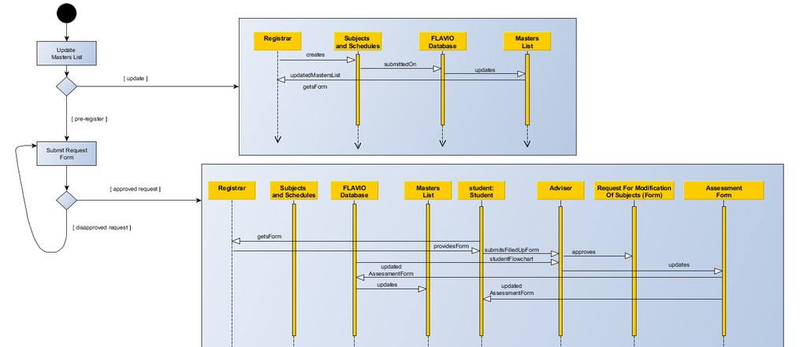

Event Table

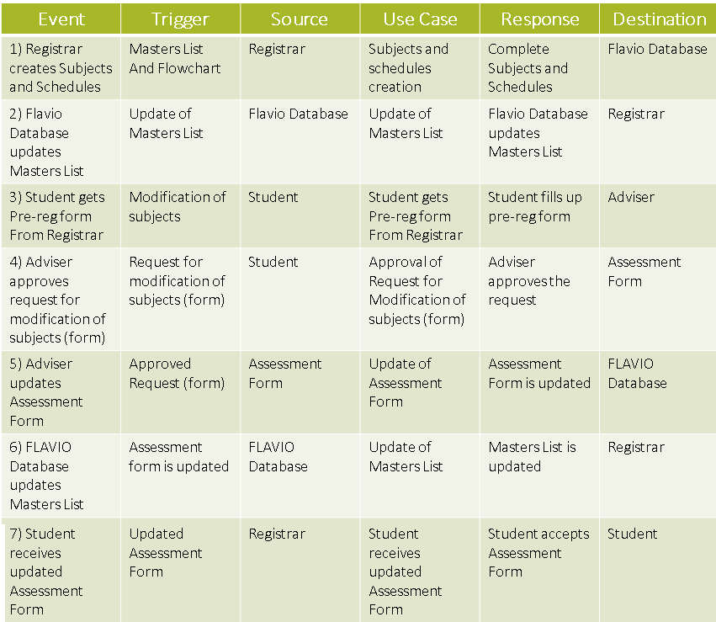

Context Diagram

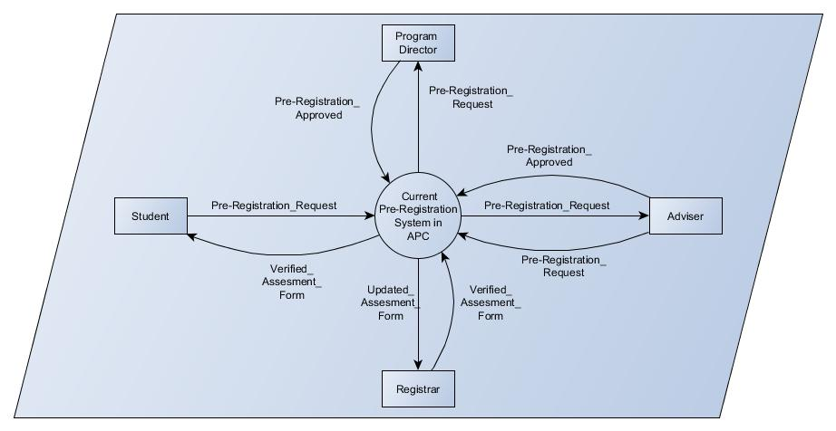

Diagram 0

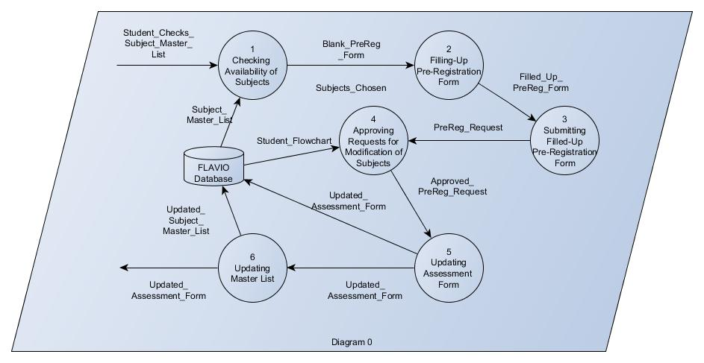

Diagram 1

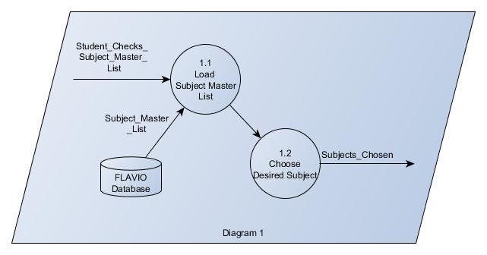

Diagram 2

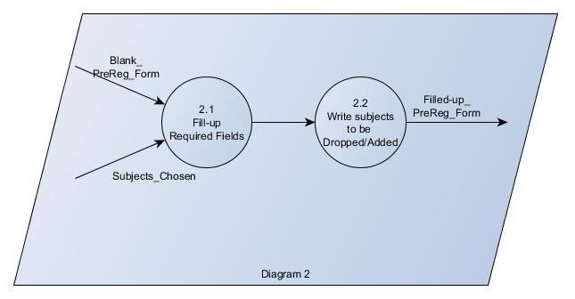

Diagram 3

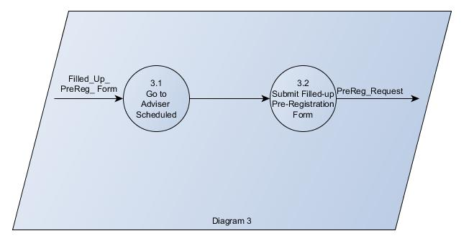

Diagram 4

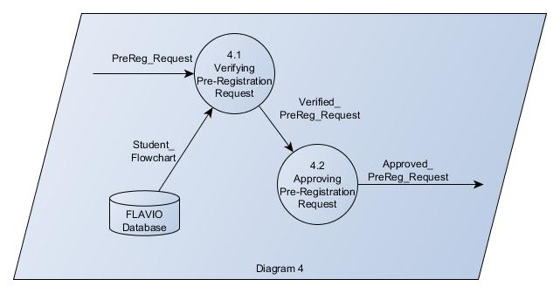

Diagram 5

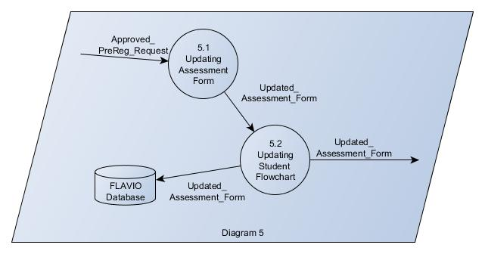

Diagram 6

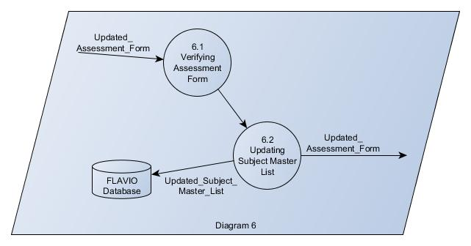

INITIAL PROPOSED DESIGN

